NAME: AKINLABI COLLINS AYOMIDE
MATRIC NO: 220404051
COURSE CODE: CSC 426
LECTURER: DR. AJAYI

SOLUTIONS
- Google form link: https://forms.gle/eHNRwbmiSL4Z5qaT6

- (Ishikawa Diagram will be added to the Github Repository also)

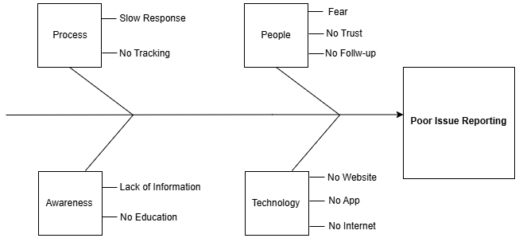

- https://iroweb.netlify.app/ (Code File are uploaded to Github Repository)

- Use Case Diagram

Actors
- Student
- Indigene

Use Cases
- View Home Page
- Learn About IRO
- Report an Issue
- Upload an Image (Optional)
- Receive Submission Confirmation
- Track a Report
- Contact the Support Team
- Browse Frequently Asked Questions (FAQ)
IRO Web home page

All Reports
Including:
i. Report ID
ii. Reporter
iii. Issue
iv. Status
v. Actions
Admin
Page
Contact Page
FAQ Page
Track Report Button
Input Report ID
Track Report Page
SUBMIT Button
NAME
STUDENT/INDIGENE
FACULTY
DEPARTMENT/LEVEL
ISSUE TYPE
LOCATION
ISSUE TITLE
DESCRIPTION
IMAGE UPLOAD
Report Issue Page

e. Software Requirement Specification (SRS)

Introduction
The Issues Reporting Outlet (IRO) is a responsive web interface designed to provide AAUA students and nearby community members (Akungba, Iwaro, Etioro, Ayegunle, and surrounding areas) with a simple platform for reporting social, environmental, security, and infrastructural issues. The interface demonstrates how users can submit reports, track report status, and access relevant information through an intuitive web application.

Objectives
The objectives of the IRO web interface are to:
- Provide a simple and user-friendly issue reporting interface.
- Demonstrate the workflow of an online reporting platform.
- Enable users to simulate reporting community-related issues.
- Provide a sample report tracking interface.
- Present a responsive design suitable for desktop and mobile devices.

Users
The intended users of the interface are:
- AAUA Students
- Community Indigenes (Akungba, Iwaro, Etioro, Ayegunle, etc.)

Functional Requirements
The interface shall:
- Display information about the IRO platform.
- Allow users to complete an issue reporting form.
- Allow users to upload an image as supporting evidence.
- Generate a sample report identification number using JavaScript.
- Display a confirmation message after report submission.
- Allow users to enter a report ID to simulate report tracking.
- Display sample report status information.
- Provide contact information through a contact page.
- Display frequently asked questions (FAQs).

Non-Functional Requirements
The web interface shall:
- Have a clean and user-friendly design.
- Be responsive across desktop, tablet, and mobile devices.
- Load quickly in modern web browsers.
- Use simple and consistent navigation.
- Be easy to maintain and update.
- Provide basic client-side form validation.
- Be compatible with deployment on static hosting platforms such as Netlify.

System Components
Users

Responsive Web Interface

HTML Structure

CSS Styling

JavaScript Interactiom

Inputs
The interface accepts the following user inputs:
- Full Name
- User Category (Student or Indigene)
- Faculty or Community
- Department/Level
- Issue Type
- Issue Title
- Issue Description
- Location
- Image Upload (Optional)
- Report ID for Tracking

Outputs
The interface provides the following outputs:
- Submission Confirmation Message
- Automatically Generated Sample Report ID
- Simulated Report Status
- Contact Information
- Frequently Asked Questions

Other Requirements
The development of this interface assumes that:
- Users have access to a modern web browser.
- Users have an internet connection to access the hosted website.
- Report submission and tracking are simulated using client-side JavaScript only.
- No server-side processing, database, or user authentication is implemented, as the project is intended to demonstrate the frontend interface only.

